Setting Up Your Student Account in CATEMA
Go to www.catema.com, and select Riverside Community College District from the menu on the first page

On the bar across the top, select NEW STUDENTS, then CREATE ACCOUNT

Fill in your information. Your 7 digit Student ID number that was emailed to you from the college goes in the College ID field:

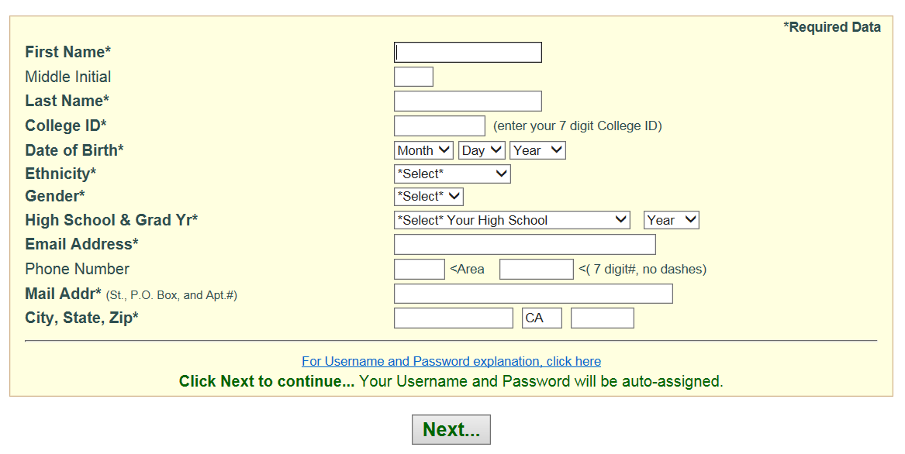

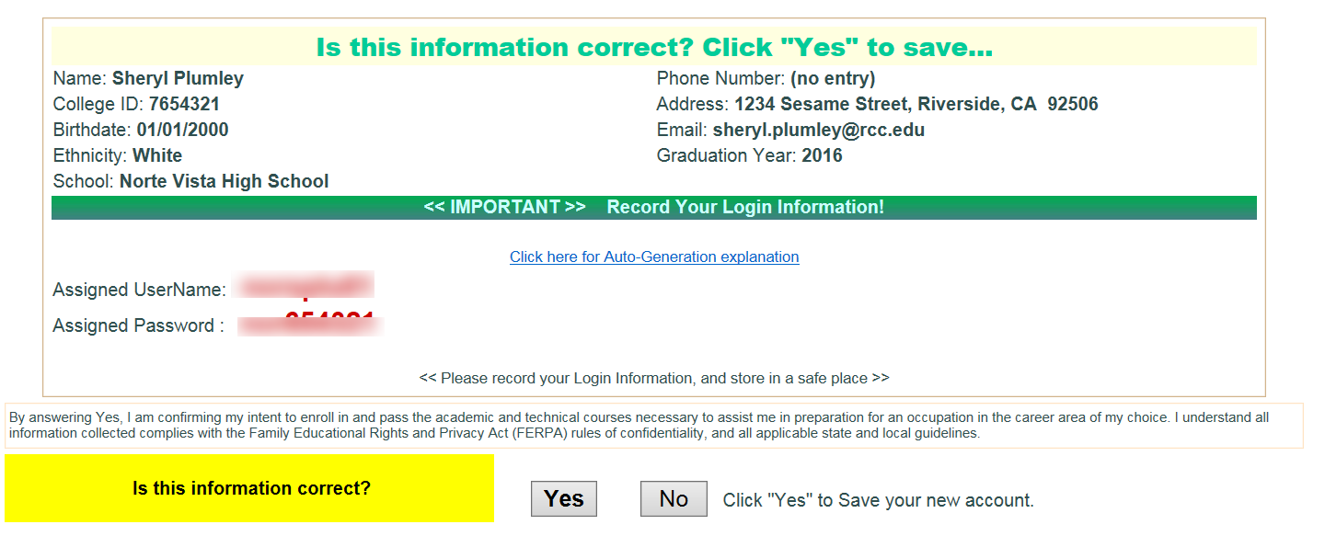

Verify your information, WRITE DOWN YOUR USERNAME AND PASSWORD. Then click YES.

Then an Enrollment Application screen will open. From the drop down menus, select your SCHOOL, then your TEACHER, then the CLASS NAME, then your CLASS PERIOD. And finally, click SUBMIT.

